| **Test Name** | | | Test Correct balance increase after win | | | |
| --- | --- | --- | --- | --- | --- | --- |
| **Use Case Tested:** | | | T002: Payment of winning game increase player balance | | | |
| **Test Description:** | | | Test if the balance increases when the player wins on 1 match. The game should pay 1 to 1. | | | |
| **Pre-conditions** | | | Run the program with the pre-entered player’s details. | | | |
| **Post-conditions** | | | The game should pay 1 to 1; in other words, the player’s balance has increased by 1x | | | |
| **Notes:** | | **Junit module will reproduce the bug.** | | | | |
| **Result (Pass/Fail/Warning/Incomplete)** | |  | | | | |
|  | **TEST STEP** | | | **EXPECTED TEST RESULTS** | P | F |
|  | Run the program pre-entered player’s details:  Player name = “Fred”  Balance = 100  Limit = 0 | | | Console opens and show the result for 100 games. | P |  |
|  | Look for a game If player wins with 1 match, balance should increase by 1x game’s bet. | | | The player’s balance increases by 1x the bet. |  | F |
|  |  | | |  |  |  |

|  |  |  |  |  |  |
| --- | --- | --- | --- | --- | --- |
| **Test Data Table** | | | | | |
|  | **1** | **2** | **3** | **4** | **5** |
| Player | “Fred” | “TestPlayer” |  |  |  |
| Balance | 100 | 20 |  |  |  |
| Limit | 0 | 0 |  |  |  |
| Bet | 5 | 4 |  |  |  |

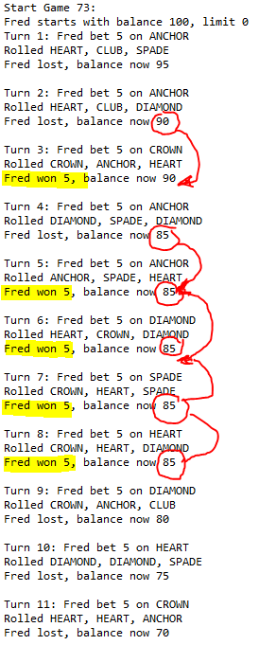As we can see, every time that Fred wins, the game does not pay 1 to 1 as it should be. The same bug occurs when the symbols appears in two dices and the payment should be 2 to 1; however, the payment is just 1 to 1.

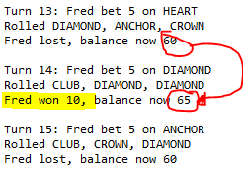

The T002_test is trying to replicate the error with a Junit file. However, the test fail because the bug is affecting the balance after a winning game.

